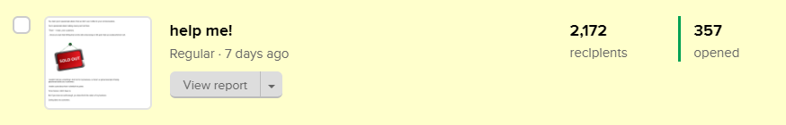
357 opened this email: https://preview.mailerlite.com/j8a7q3
--------------------------------------------------------------------------------------------------------

Headline: help me!
———————————————-

You claim you’re passionate about it but we don’t see it reflect in your communications.

You’re passionate about making money and not them.

“Them” - I mean, your customers.

{$name}, I know you want that feeling that comes with announcing on the gram that your product/service are;


I wouldn’t tell you something I don’t do for my business, so here’s a typical example of being passionate about your customers.

I made a post about how I schedule my posts.

To be honest, I didn’t have to.

But if you know me well enough, you know that’s the nature of my business.

Caring about my customers.

A comment from the post;

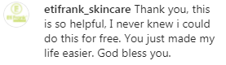

Best believe, such a customer would always have me top of mind when they need help with whatever service I provide.

You need to see your FREE content as party-small-chops that’ll have your customers stick around for the main food (your course/service/product). Hopefully, the food tastes so good that they have no choice but to invite their friends to come patronize too.

Your customers are constantly screaming “help me!” but you’re so carried away with making money, so they move on to the next person who can help.

Are you helping them or just selling to them?

Lamide.

900211, Nigeria

